Alberta Masters Provincials
April 18 - April 19, 2026
University of Calgary Aquatic Centre

Technical Bulletin #1
(Mar 8, 2026)

LOCATION
The competition will occur on University of Calgary campus, and the pool is located within the Kinesiology Building A (KNA), as shown on the attached map. The main competition (25m) will occur in the deep end (north end) of the 50m pool, and the warm-up/down pool (shallow, south end) will be open during the entire competition period.

PARKING and FINDING POOL
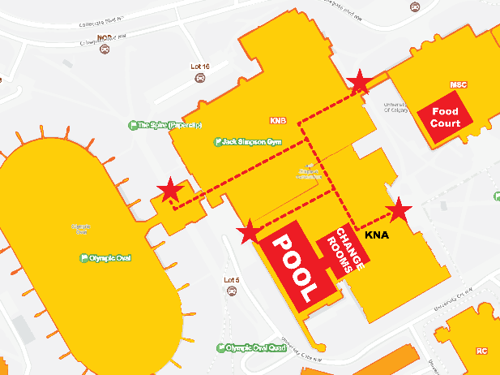
There is no free parking on campus, but the most economical is Lot10 (L10 on the attached map), which is $6 per day on weekends, then walk over to the pool in KNA building. There are closer parking lots, and rates vary depending on convenience (Lot 9, $6/hr; Arts Parkade, $12/day). Once parked, there are several entrances that can be used to get to the pool, as shown by stars on the map to the right. The dotted lines approximate the interior hallways to the changerooms. All athletes must enter/leave the deck through changerooms. There is separate deck access for officials.

PLACES to STAY
There are several options to stay that are walkable to the pool. The closest hotel is Alt Hotel (https://www.germainhotels.com/en/alt-hotel/calgary-university-district) in the University District. Alternatively, there is a cluster of hotels near McMahon stadium, such as: Holiday Inn Express & Suites Calgary NW, Best Western Plus Village Park Inn, Hampton Inn & Suites by Hilton Calgary-University, Aloft Calgary University, Econo Lodge Inn & Suites University, or Comfort Inn & Suites University.

CLEAN-UP
The University of Calgary has asked that swimmers take time to clean up after themselves while on the pool deck and sort their waste into designated bins located throughout the facility. Do NOT bring glass containers onto the deck.

REGISTRATION DESK
The registration desk will be located on deck near the changeroom entry/exit.

OTHER IMPORTANT POINTS TO NOTE
Results will be posted on Meet Mobile.
Heat sheets will be provided to coaches and officials only. Heat sheets will be available on Meet Mobile as well.
Please remind all swimmers of the warmup rules, as they will be adhered to during each warmup session.

Scratches: As per the Swim Alberta Scratch Rule

All known scratches to be submitted to the Meet Manager prior to the start of the meet.

